Autici se krecu

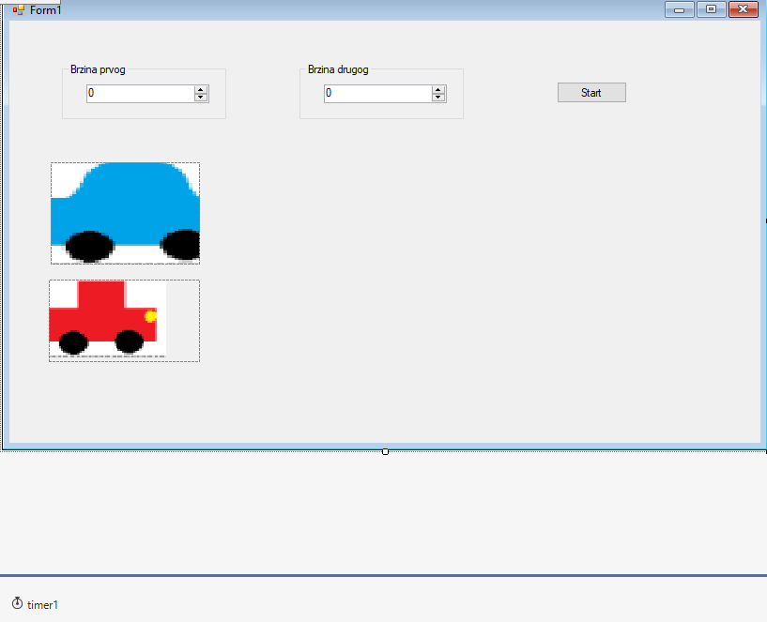

GoupBox1-NumericalUpDown;

Timer1; PictureBox-Image;

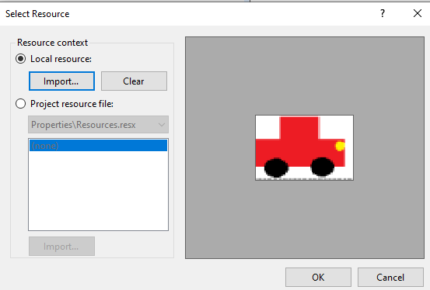

**namespace WindowsFormsApp2**

**{**

**public partial class Form1 : Form**

**{**

**public Form1()**

**{**

**InitializeComponent();**

**}**

**private void button1_Click(object sender, EventArgs e)**

**{**

**timer1.Start();**

**}**

**int v1, v2;**

**private void numericUpDown1_ValueChanged(object sender, EventArgs e)**

**{**

**v1 = (int)numericUpDown1.Value;**

**}**

**private void numericUpDown2_ValueChanged(object sender, EventArgs e)**

**{**

**v2 = (int)numericUpDown2.Value;**

**}**

**private void timer1_Tick(object sender, EventArgs e)**

**{**

**pictureBox1.Left += v1;**

**pictureBox2.Left += v2; } }}**